**Harris Corner Detection**

Sucheta Ravikanti (160040100)

Swadha Sanghvi (16D070037)

Neharika Jali (160040101)

The following two image represents the derivative along the y axis or the vertical derivative and the horizontal or the derivative along the x-axis of the given image respectively.

**Vertical or derivative along y-axis :**

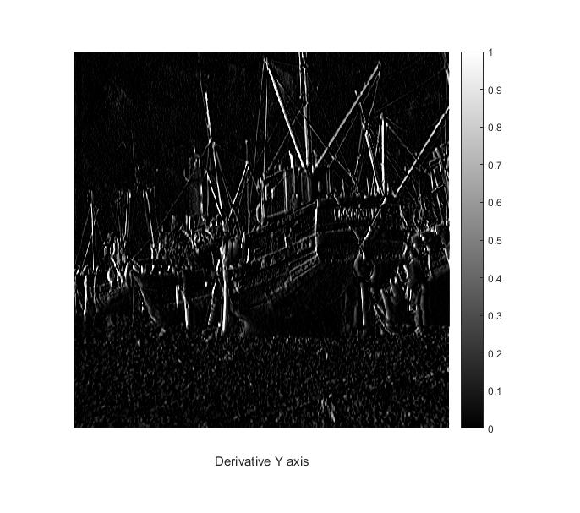

**Horizontal or derivative along x-axis :**

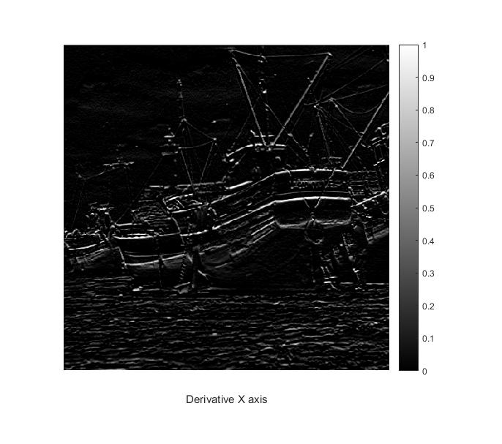

**Image of the smaller and greater eigenvalue of the structure tensor evaluated at each pixel respectively :**

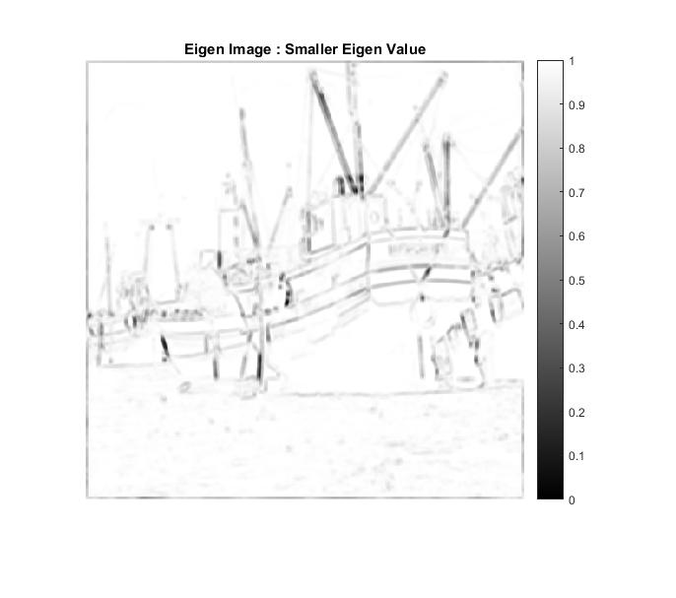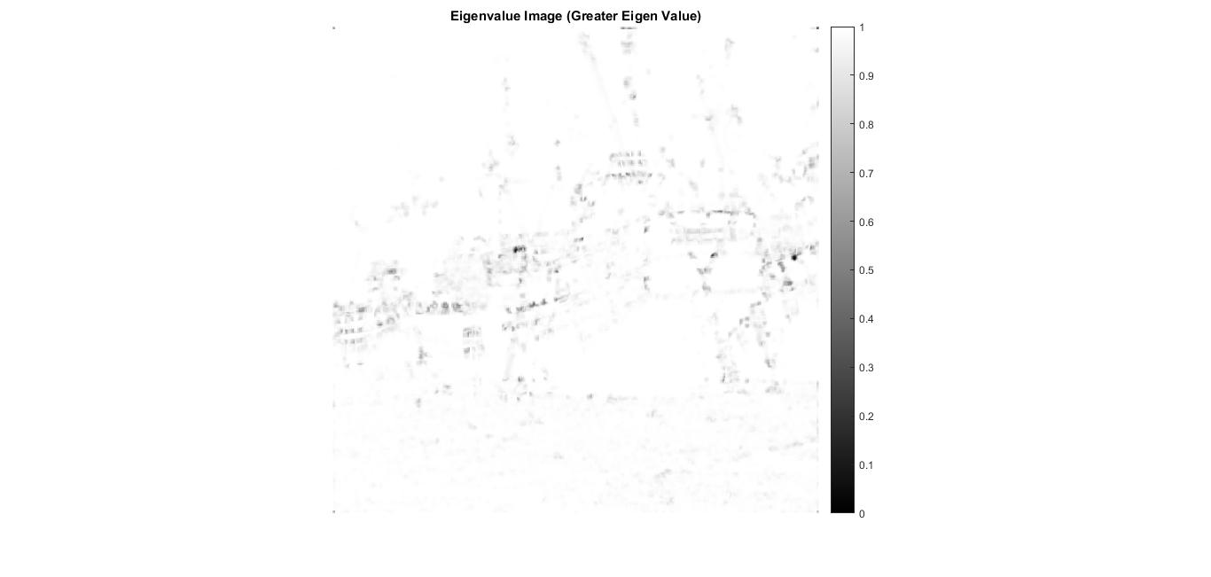

**Note: Please check the folder corresponding to the output Images for clearer images**

**Harris Cornerness Measure :**

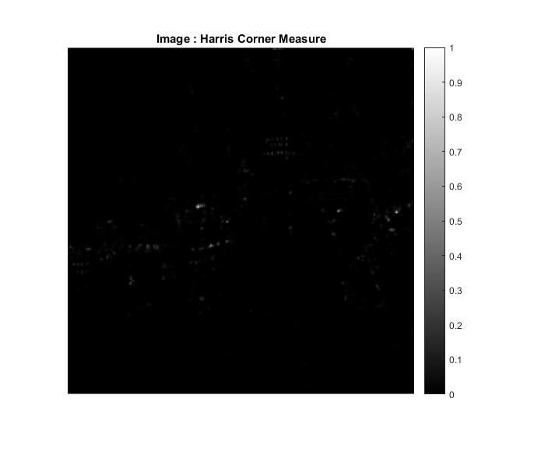

**Histogram of the Harris Cornerness measure :**

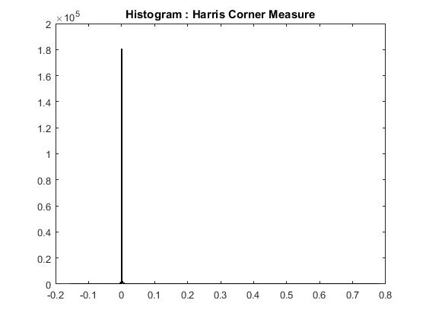

**Post thresholding Image of the harris corner detection output :**

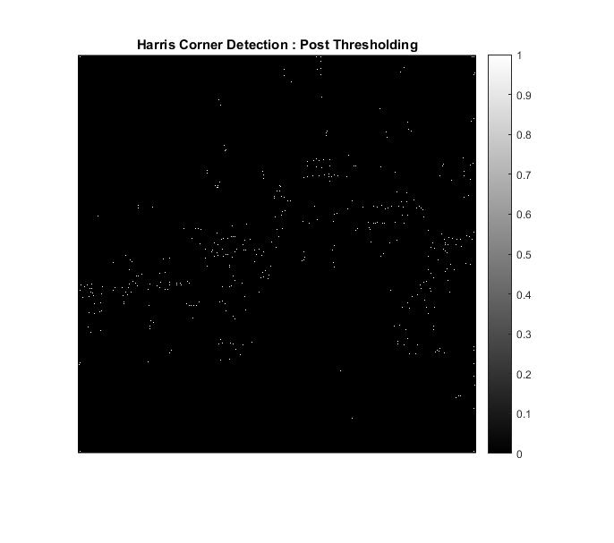

**Final Image with corners marked**

Parameters used :

* **Window size = 5X5 (Window deciding the weights of the neighbours)**
* **K = 0.03 (used in calculating the harris corner measure)**
* **Sigma_1 = 3 (Variance for the gaussian filter for smoothing the derivatives)**
* **Sigma_2 = 0.01 (Variance for the gaussian filter for smoothing the input image)**

